**ABDURRAFIQ BIN ZAKARIA|** A24CS0031

**DANIEL IMAN HAQIMIE BIN YUSOFF |** A24CS0063

**PROGRAMMING TECHNIQUE 1 |** SECJ1013

**MRS. LIZAWATI MI YUSUF |** LECTURER

FLOWCHART

**UNIVERSITI TEKNOLOGI MALAYSIA**

**BMI CALCULATOR**

**Introduction to BMI (Body Mass Index)**

BMI, or Body Mass Index, is a handy way to see if someone’s weight is healthy for their height. By looking at both height and weight, it gives an idea of body fat and sorts people into categories like underweight, normal weight, overweight, or obese. These categories can change based on age and region. While BMI isn’t perfect, it’s a useful tool to spot potential health issues related to being too heavy or too light, and it can help decide if more health checks are needed. [1] (calculator.net, 2008-2024)

**Exclusions and Inclusions**

For this flowchart, we’ve decided to exclude the more detailed separate severity levels of underweight and obesity, we’d like to keep the process more simplified, without clutter, and in short terms for the user to easily understand their current BMI classification. The calculator is also able to read US units (the Imperial system) should the user wish to use the units. This is to have some inclusion for certain users who are not familiar with the metric system.

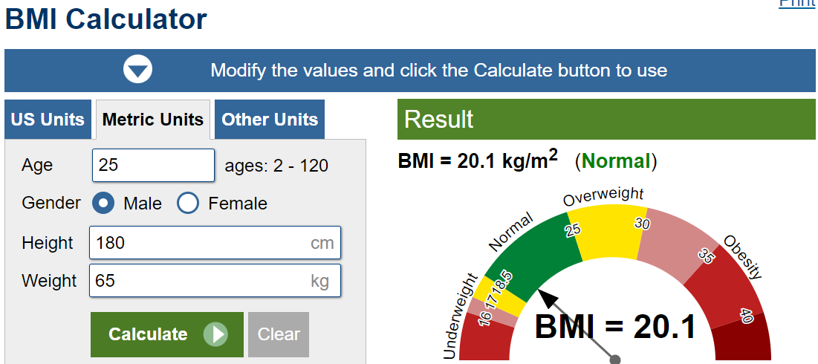

**Figure 1**: Screenshot of BMI Calculator Application

***Image obtained from*** [*https://www.calculator.net/bmi-calculator.html*](https://www.calculator.net/bmi-calculator.html)

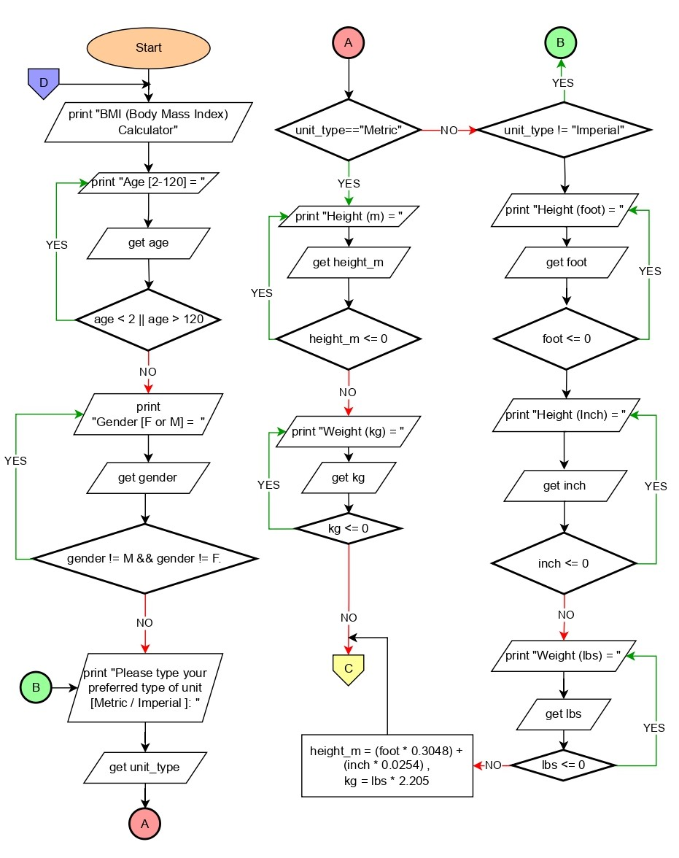

**Figure 2a:** Screenshot of BMI calculator flowchart

***Image made using*** [*https://www.drawio.com/*](https://www.drawio.com/)

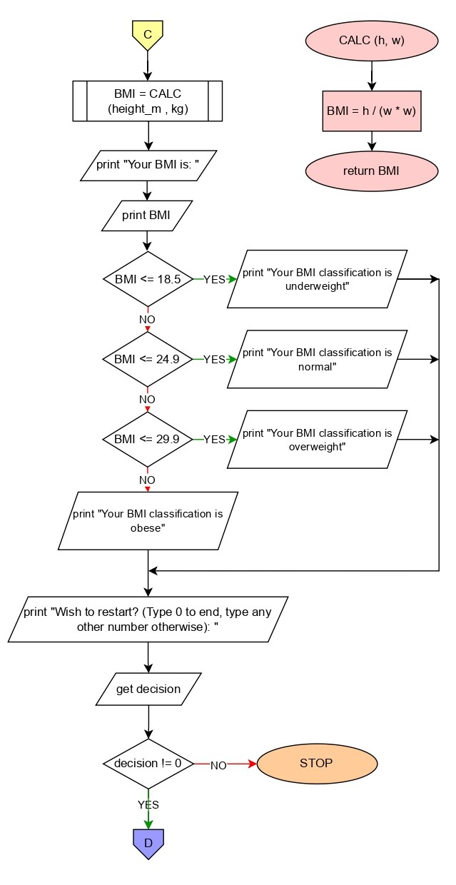

**Figure 2b:** Screenshot of BMI calculator flowchart

***Image made using*** [*https://www.drawio.com/*](https://www.drawio.com/)

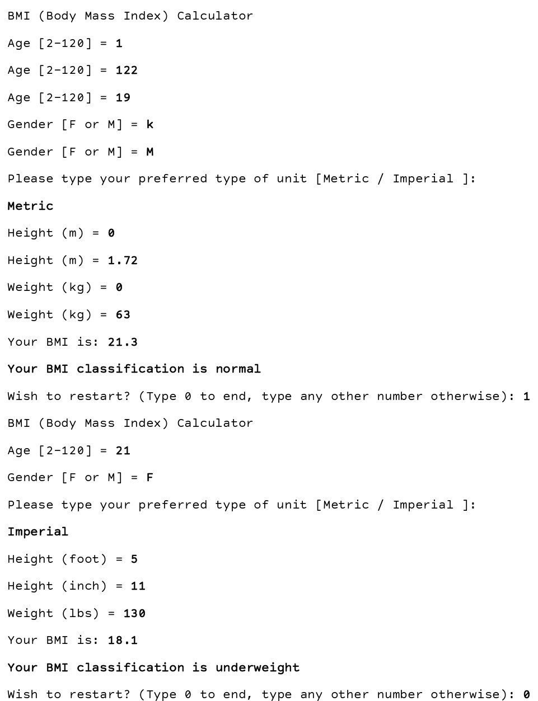

**Figure 3**: Screenshot of inputs and outputs

**REFERENCES**

1. Calculator.net.(2008-2004).BMI introduction. Retrieved from <https://www.calculator.net/bmi-calculator.html>